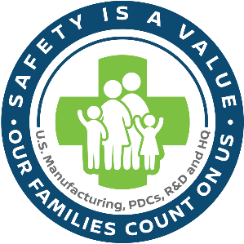Memorandum

**To:** Area Management of Employees at Nissan North America Locations

**From:** Reed Thomason (Senior Manager, Safety)

**Date:** 6/20/24

**Re:** Safety Training Program Rollout – Automotive Lifts

**Your assistance with the implementation of the Automotive Lift Safety Training Program is required.**

To help ensure the health and well-being of our employees, the Nissan Safety Department regularly develops and updates safety training programs.

The *Automotive Lift Program* was recently completed and can be found here: ([*link*](https://nissangroupnam.sharepoint.com/:b:/r/sites/NA_NNA_000574/Website%20Documents/Home/NNA%20Safety%20Programs/Automotive%20Lift%20Program%20USREG-ALI-PGM-001.pdf?csf=1&web=1&e=ag3BPy)). This training program includes important information employees need to know to work safely, such as roles and responsibilities, training requirements, potential hazards, control methods, safe work practices and additional safety requirements.

In accordance with our safety policy, management is responsible for implementing the requirements of our safety programs, and employees are responsible for following those requirements. Please communicate the program requirements to your staff, and when training is required, arrange for such training to be deployed and attended.

We appreciate your dedication to making safety our top priority. If you have any questions, please contact the Safety Engineer for your area or your manager.

Thank you for all that you do each day to make Nissan a safe place to work.